Sorghum Shuffle 5K
Sue Blair

Part of the United Way Trifecta Nelson, Marion & Washington Counties of Kentucky
Chip Timing ~ USATF Certified Course ~ Tshirts for the First 100 People Registered!

Age Divisions
*9 and under free
10-14, 15-17, 18-24, 25-29,
30-34, 35-39, 40-44, 45-49,
50-55, 56+
Sorghum Shuffle Pricing:
$20 Individuals on or before September 6th
$25 Individuals after September 6th
$16 Group 15+ on or before September 6th
$20 Group 15+ after September 11th
*Free 9 and under run free, but will not receive t-shirt.
**T – shirts may be purchased for $15.00

Swag pick-up
Includes t-shirt, exclusive *pin (*while supplies last)
When registering online, you may choose “ship my swag” for a $10.00 handling fee. Or you may pick up on the follow dates:
Wed Sept. 29th 4-5:30 pm @ 124 W Main, Springfield, Ky
Thurs Sept. 30th 4-5:30 pm @ 124 W Main, Springfield, KY
Sat Oct 2nd 6:45 am race day registration

Name________________________________________________________________________
Address______________________________________________________________________
City____________________________________________State ________ Zip________
Phone__________________________________________
Email__________________________________________________________
Age Division _____________ T-shirt Size: ________________________ (specify Youth or Adult)
Signature: _____________________________________________________________ Date: _______________

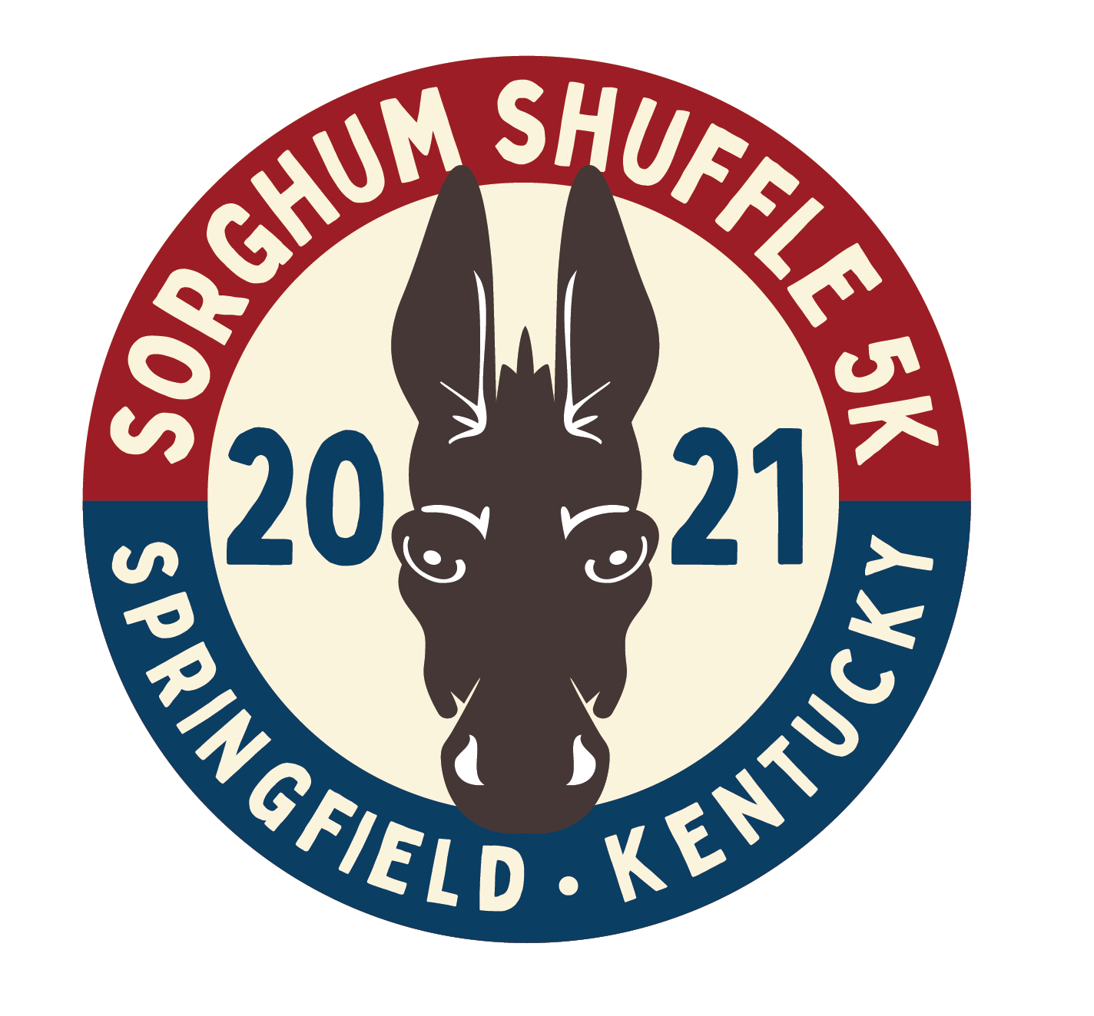
124 West Main Street
Springfield, KY 40069
859-336-5412 x 5
administrator@springfieldkychamber.com

