Small Towns Big Hearts T- Shirt Order Form

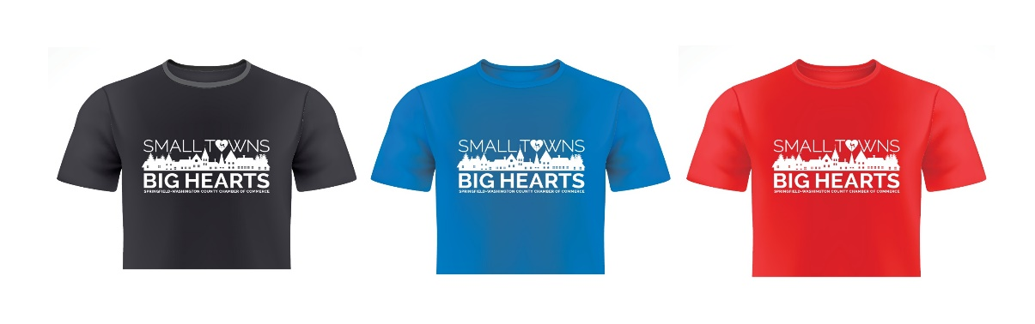
Name________________________________________________________________________
Address______________________________________________________________________
Phone__________________ Email: ______________________________________________
Color and Size: (Y = Youth, A = Adult)
Black: Youth S_____M_____ L_____
Adult S_____ M_____ L ____ XL _____
2XL_____ 3XL _____ 4XL_____ 5 XL ____(additional $2.00 for 2XL and Up)
Kentucky Blue: Youth S_____M_____ L_____
Adult S_____ M_____ L _____ XL _____
2XL_____ 3XL _____ 4XL_____ A 5 XL ____ (additional $2.00for 2XL and Up)
Louisville Red: Youth S_____ M_____ L_____
Adult S_____ M_____ L _____ XL _____
2XL_____ 3XL _____ 4XL_____ 5 XL _____ (additional $2.00 for 2XL and Up)
** Buy 5 or more t shirts @ $12.00 each ($14.00 for 2xl and up)
All orders must be prepaid. Please allow at least 2 weeks to complete.
T shirts can be picked up at the Opera House unless prior arrangements have been made.
The Chamber accepts cash, check or credit. If using a credit card, a 4% charge will be added to cover fees
Mail or drop payment:
Springfield Washington County Chamber of Commerce
124 W Main Street, Springfield KY 40069
administrator@springfieldkychamber.com
859-336-5412 x 5

Chamber use Paid: Cash $____________ Check #____________ CC ______________ QB_____

